NCU-FRM

COMMUNITY SERVICE TRACKING FORM

Review Date:

|  |
| --- |
|  |

NAME OF THE STUDENT PROGRAM

**NAME OF COMMUNITY SERVICE CLUB/SOCIETY MEMBERSHIP** Yukti , The Hood, Creater’s Garage,Udaan,Prayaas

**SEMESTER/ YEAR** 5th – Sem (3rd Year)

SIGNATURE AND DATE

(TO BE SUBMITTED BY THE STUDENT TO THE MENTOR)

|  |
| --- |
| Sheet 1 of 1 |

S.No. Recipient(s) of Services

Description of Activity Date # of hours Signature

|  |  |  |  |  |
| --- | --- | --- | --- | --- |
| 1  2  3  4  5  6  7 | NGO Visit - Yatan NGo    Caption Writing Event  Art Therapy Workshop  Jhanda - E - Shaan  Animal Food Feeding Drive  Awareness quiz on Ban of SUPs  Webinar on Sociall Well Being | We Have to visit any ngo and share good deeds with children.  Write caption Event  Webinar Participated.  Brought a flag from Nearest Post Office and hosted on top of house  Feed Stray Animals  Quiz  Webinar Participated. | By Yatan  By Udaan  By Manovriti  By Aashayen and Udaan  By Prayaas  By IEEE HAC  By Creator's Garage | 40  3  2  2  10  1  2  ***Total Hours***  ***60*** |

• Student have to provide a report on work done under each activity. Detailed report along with photographs/video and certificates obtained from NGOs/NCU Societies is to be submitted (annexure).

TO BE FILLED BY MENTOR

|  |
| --- |
| • DATE OF RECEIPT OF SERVICE 40.5  • LIST OF PROOF(S):              REMARKS  • SIGN WITH DATE: |

Annexure

The NorthCap University, Gurugram

Date: 9th November 2022

Index

Objective: Visit to ngo

Name of the activity: Ngo Visit - Yatan

Certificate

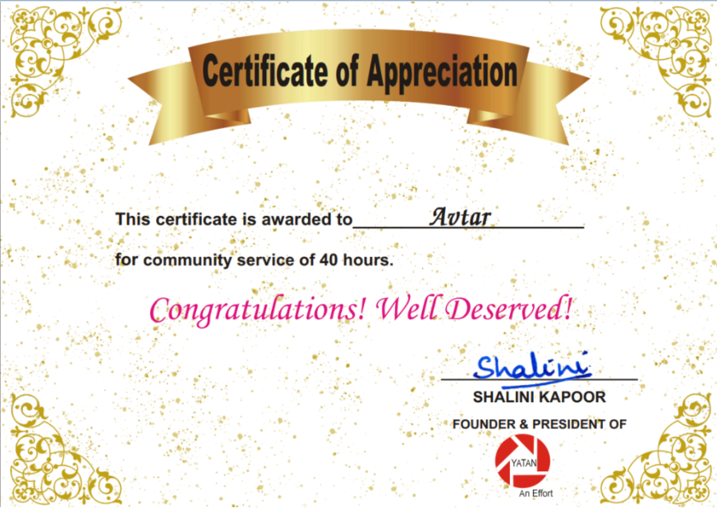

Contributions One of the Head

Photographs/ Videos

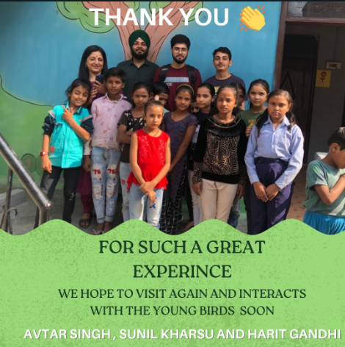

Conclusion

Date: 17th November 2022

Index

Objective: Webinar on Art Therapy

Name of the activity: Art Therapy Workshop

Certificate

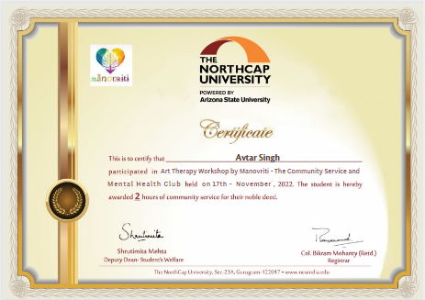

Contributions

Photographs/ Videos

Conclusion

Date: 11th - 15th November 2022

Index

Objective: Write Caption for Independence day

Name of the activity: Caption Writing

Certificate

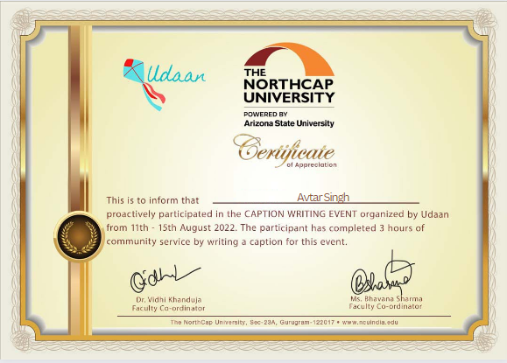

Contributions Submitted Captions

Photographs/ Videos

Conclusion

Date: 11th - 15th November 2022

Index

Objective: Flag hosting at home

Name of the activity: Jhanda - E - Shaan

Certificate

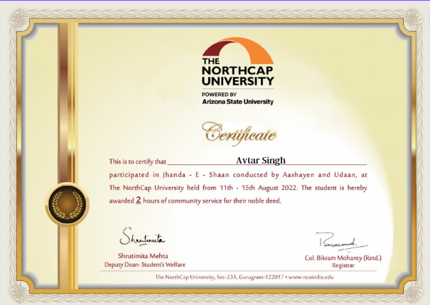

Contributions Hosted Flag

Photographs/ Videos

Conclusion

Date: 28th October 2022

Index

Objective: Webinar on Wellness

Name of the activity: Social Welbeing - Going beyond individual

Certificate

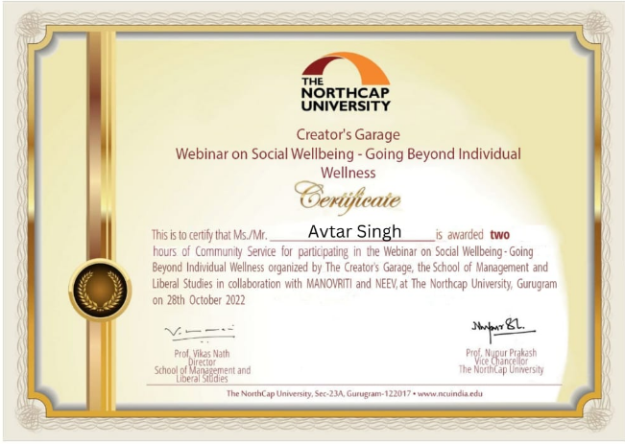

Contributions Participation

Photographs/ Videos

Conclusion